742 Delaware Avenue
Buffalo, New York 14209
Phone: 716-887-2757
Fax: 716-887-2770
E-mail: nfprc@uwbec.org
www.uwbec.org

Not For Profit
Resource Center

Train For Nonprofit Board Service

Meet Nonprofits with Board and Committee Openings

If you would like to serve on a nonprofit Board, you might ask:

- How do I prepare myself for service?
- Which nonprofits might like my help?

United Way of Buffalo & Erie County will help you answer those questions. This will be a joint training with the United Way Leaders of Change and other professional organizations. While training is not required for nonprofit board service, it is very helpful.

- Board Responsibilities & Procedures
- Legal and Fiduciary Responsibilities
- Strategic Planning & Marketing
- Fundraising

At the final session, you will participate in a Networking Session with several nonprofit organizations. Last year, 45 nonprofits attended this session. These nonprofits will have current or expected openings on their Boards or Board Committees. As a result of this session, you might find a perfect match for your interests.

Sessions will be held Thursdays at Classics V, 2425 Niagara Falls Boulevard, Amherst, NY 14228. You should attend all four sessions if possible. The sessions are 4:30-7:00 p.m.

April 26, May 3, May 10, May 17

The price is $80 for the entire series, which includes a buffet dinner every evening and materials. United Way Leaders of Change donors (gift of $1,000 or more) will receive a 25% discount.

Please RSVP to Bernie Miltenberger at United Way, bernie.miltenberger@uwbec.org or 887-2746, as soon as possible.

Payment is due by March 30. Please use the following form for payment.

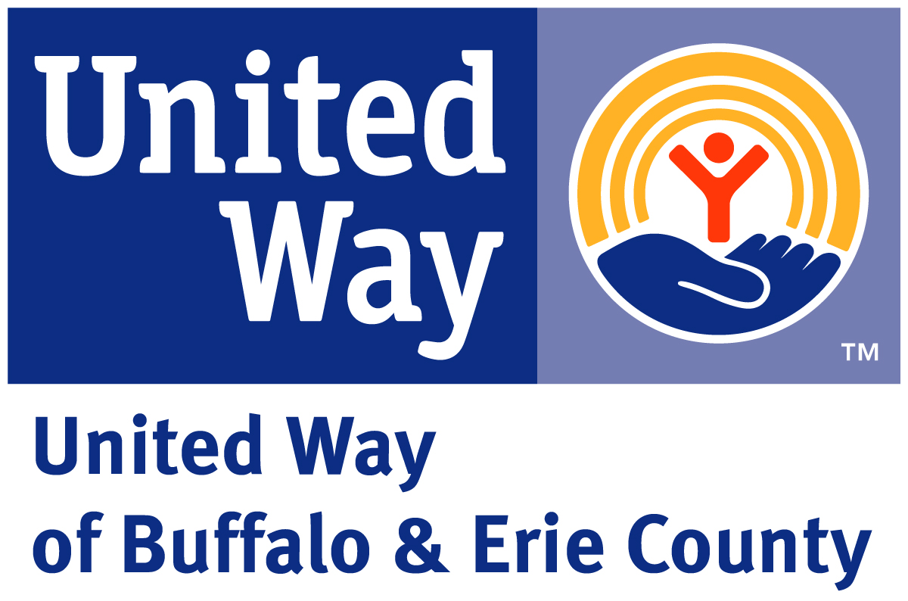

SPACE IS LIMITED!!

YES! I will be attending the 2012 Board Leadership Training and enclosed is payment to hold my space.

Name you would like to appear on your Tent card and Name Tags:

____________________________________________________________________________
Please Print

Phone:____________________ E-Mail_____________________________________________

Payment Options

__ I am a United Way Leaders of Change donor and enclosed is a check for $60.00 made payable to United Way of Buffalo & Erie County

__ Enclosed is a check for $80.00 made payable to United Way of Buffalo & Erie County

__ Use this link to register and pay online by credit card http://www.uwbec.org/calendar

__ Credit Card: __Visa __Mastercard __American Express __Discover

Name as it appears on card _______________________________________________________

Credit Card #__________________________________________ Exp. Date _________________

Signature ____________________________________________ Date _____________________

Mail to:
United Way of Buffalo & Erie County
2012 Board Leadership Training
742 Delaware Avenue
Buffalo, NY 14209

You will receive confirmation of your enrollment. Email any questions to Bernie Miltenberger at bernie.miltenberger@uwbec.org or 887-2746.

